Health care analysis

Database schema:
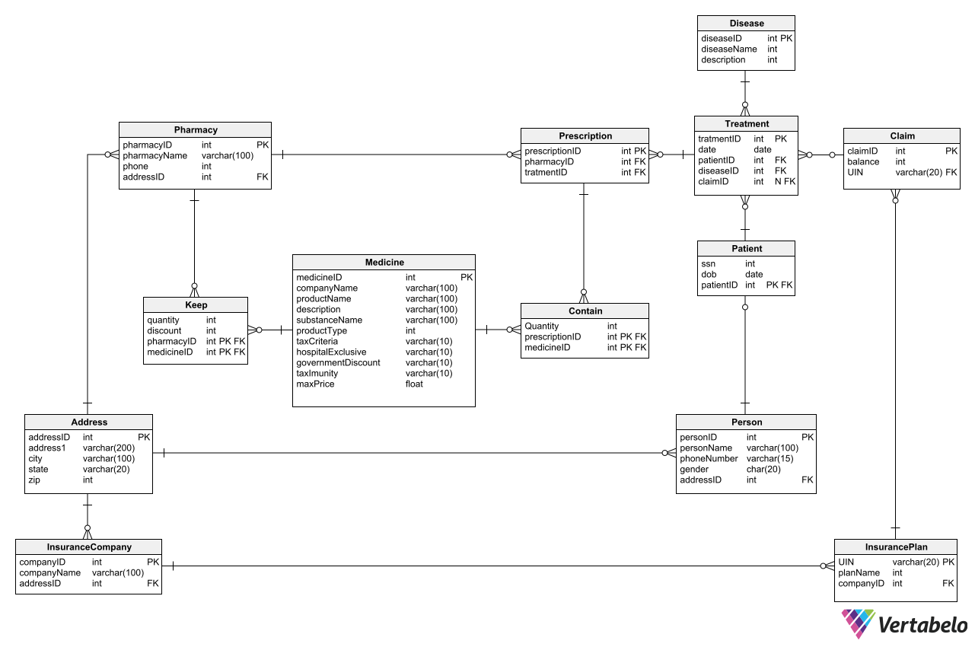

Objective
The primary objective of this project is to design and implement a comprehensive healthcare data analysis system that seamlessly integrates multiple data sources, including patient records, insurance details, prescriptions, and pharmacy inventories. The system will establish efficient ETL processes to handle large-scale healthcare datasets while ensuring data cleaning and standardization for accuracy and reliability. Advanced queries and analytics will be performed using PySpark, Hive, and Spark Streaming, supporting both batch and real-time data processing. To enhance decision-making, interactive dashboards and visualizations will be developed in Power BI, providing healthcare providers and insurers with actionable insights into patient care, resource utilization, and insurance management. Overall, the project aims to improve healthcare outcomes and operational efficiency through data-driven intelligence.

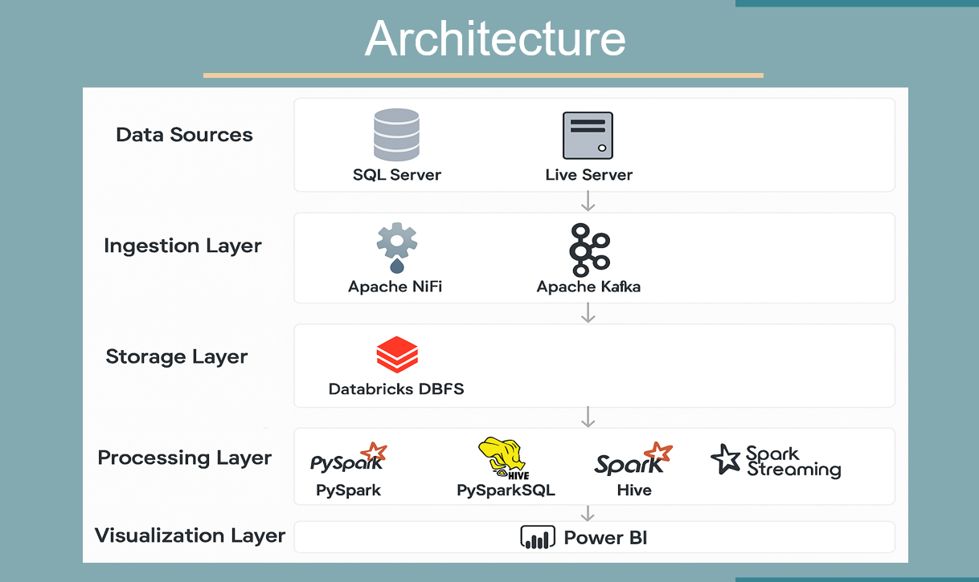

CSV Files and Descriptions
- Person: Stores personal details of individuals such as name, phone number, gender, and address reference.
- Patient: Represents patients with unique SSN and date of birth, linked to address.
- Address: Contains address details including street, city, state, and zip code for persons, pharmacies, and insurance companies.
- Disease: Holds information about diseases including name and description.
- Treatment: Links treatments to claims and diseases, representing medical procedures.
- Claim: Represents insurance claims associated with treatments and linked to insurance plans.
- Insurance Company: Stores details of insurance companies including name and address.
- Insurance Plan: Represents insurance plans offered by companies, identified by UIN.
- Pharmacy: Stores pharmacy details such as name, phone, and address.
- Prescription: Links prescriptions to pharmacies and treatments.
- Medicine: Contains details of medicines including product name, description, price, and manufacturer.
- Contain: Junction table linking prescriptions to medicines with quantity information.
- Keep: Tracks medicine stock in pharmacies with quantity details.

